Risk Assessment: residential special school only pathway
The information in this assessment is confidential to the student, family, local learning support team, the regional prioritisation panels for intensive support and the residential special school principals.
This assessment is completed by the referrer before a young person starts at a residential special school (RSS) and is submitted with the application form.
This assessment is current for the date it was written. It is acknowledged that further risk assessment maybe needed once the young person has started at a RSS.
Young Person’s Name: | DOB: | Date:
Caregiver Name: | Phone: | Address:
Current school |  | Phone:
The purpose of this assessment is to highlight and identify where possible, the nature and level of any risk to the child/young person and others. Risks are identified so subsequent planning and decision making can maximise supportive environments where child rights, safety, wellbeing, belonging, participation and learning are effectively supported.
This assessment will also ensure that the rights of children and young people are given due weight in accordance with their age and maturity, on an equal basis with other children, when a RSS application is being considered.

Focus of this assessment
(as agreed by the team in the home region)
Possible questions, add bullet points under relevant questions.
Why is a residential placement being considered? What educational needs would be met?
What elements of a RSS environment (such as communal living, distance from home, number of care staff) might result in risks for this young person or for others?
What are the risks of not making any changes to the schooling and learning support provided for this young person?

Sources of Information
Reports/Documentation: | Interviews/Meetings: | Observations: | Specific Tests/Other:

Declaration of Rights and Freedoms

The young person has had the opportunity to express their opinion regarding a RSS placement, and their views are being given due weight in accordance with their rights, age and maturity:

☐ Yes ☐ No

Young Persons Comments (quote where possible)
Prompt questions, add bullet points under relevant questions.
What steps have been taken to ensure the young person understands that attending a RSS means that they may not live at home during term time and go to school in their local community?
Has there been an opportunity to visit a RSS? Is a future visit planned?
How have conflicts of interest and undue influence by others been managed?
List the activities and resources required by this young person to support conversations to maintain their ongoing (informed) consent about attending a residential school and being away from home eg. visual supports, site visits, text messages.
Who are the people from the young person’s current family or support networks who will regularly connect with and check-in with the young person while they are away from home?

The family/whānau have had the opportunity to express their opinion regarding a residential school placement for their young person:

☐ Yes ☐ No

Family/whānau Comments (quote where possible)
Prompt questions, add bullet points under relevant questions.
Has the young person been involved in other respite or residential placements? How did they respond to this?
How will ongoing family engagement with the young person be supported?
How will conflicts of interest and undue influence by others been managed?
Has the risk that the family will not want this young person to return home be considered? How will this be mitigated?
How often should the section 9 agreement for this young person be reviewed?

Assessment Findings
Using Te Whare Tapa Whā provide statements to represent ‘best health’ for the young person
Te Taha Tinana (physical wellbeing)
Te Taha Wairua (spiritual wellbeing)
Te Taha Hinengaro (mental and emotional wellbeing)
Te Taha Whanau (social wellbeing including matauranga, learning and knowledge)

Assessment of specific risk(s) in relation to this young person and a residential special school setting
Please include risks relating to
- previous history including neglect, harm to self or others (including fire lighting, sexual abuse), social behaviours, mental health issues (including anxiety and depression), child or young offending and physical health.
- future risks which are likely to impact on the young person in a RSS context.
Note: Although future risks are not known you are asked to consider potential risks.
Note: Suicide risk assessments are not completed by education professionals. Refer to MOH.

Description of Risk:
Risk estimate*:
- Likelihood (Frequency):
- Potential Impact:
- Risk Estimate =

Context:

(Triggers, Antecedents, Consequences)

Mitigation strategies:

Description of Risk:
Risk estimate*:
- Likelihood (Frequency):
- Potential Impact:
- Risk Estimate = \

Context:

(Triggers, Antecedents, Consequences)

Mitigation strategies:

Description of Risk:
Risk estimate*:
- Likelihood (Frequency):
- Potential Impact:
- Risk Estimate =

Context:

(Triggers, Antecedents, Consequences)

Mitigation strategies:

Analysis Summary and Recommendations for RSS
(including young person’s perspective and recommended length of placement and rationale)

Author:
Title:
In Consultation with (peer reviewer):
Date:
Managers sign off of risk assessment
Date:

For Reference: Risk Matrix
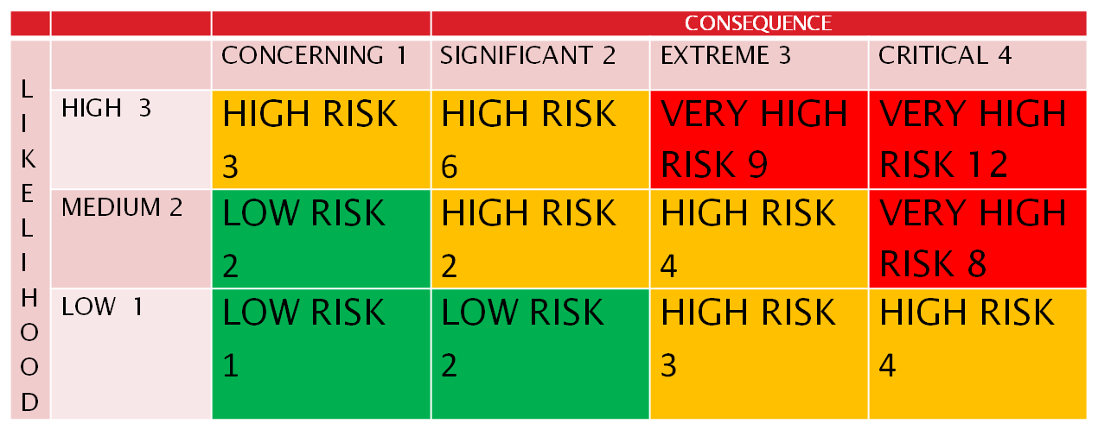

*Terms used in risk analyses:

Likelihood estimates: are made with reference to the following continuum:
Low: | The chance of the behaviour occurring is low, e.g., the behaviour leading to the risk assessment is the first instance of this behaviour, or a similar event may have occurred but not within the past three months (long term).
Medium: | There is a moderate chance of the behaviour occurring, e.g., instances of similar behaviour have occurred in the last few weeks (medium term).
High: | There is a high chance of the behaviour occurring, e.g., Similar behaviours have been occurring on a daily basis or several times during a day (short term).

Impact or consequence estimates: are made with reference to the following continuum:
Concerning: | The behaviour is likely to have little impact, but may elicit worry or concern in people connected with the event.
Significant: | The behaviour is likely to, or has the potential to, cause minimal harm.
Extreme: | The behaviour is likely to, or has the potential to, necessitate a level of ‘first-aid’ intervention.
Critical: | The behaviour is likely to, or has the potential to, cause life-threatening harm and require urgent and immediate intervention.

Professional judgement statements: The overall Risk Estimates are based on a combination of the likelihood and impact estimates, and relevant context factors. Risk estimates are considered on a continuum such as:
 | Low Risk Moderate Risk High Risk Very High Risk

Considering the rights and freedoms of children and young people with disabilities when providing residential special schooling.

- Respect the rights, will and preferences of the young person  - Requests for residential special school shall be for the shortest time possible and progress is regularly reviewed  - Decisions are proportional and tailored to the young person’s circumstances | The Convention on the Rights of Persons with Disabilities, article 7.3, states that ‘children with disabilities [should] have the right to express their views freely on all matters affecting them, their views being given due weight in accordance with their age and maturity, on an equal basis with other children, and to be provided with disability and age-appropriate assistance to realize that right.’  The Ministry and all involved will ensure that when a RSS is being considered, the young person has been provided with the opportunity to freely express their views in ways that are free from coercion or influence of others and that their views are given due weight to the decision being made and outcome of those decisions.  If required, the young person shall be provided with disability and age-appropriate assistance in order to understand the information, range of options and possible decisions about schooling, so as they can engage in the decision making process, on an equal basis as any other young person.  The Ministry and all involved will ensure the young persons’ views are represented in the application form, risk assessment and section 9 application. If the young person wants to move out of a RSS this can trigger a Section 9 review.  The Ministry and all involved will uphold and respect the rights, will and preferences of the young person and ensure they are free of conflict of interest and undue influence from other parties to the decision making process. The application process will ensure that any decision about enrolment with a residential special school is appropriate to the young person’s circumstances and will apply for the shortest time possible to meet that young person’s educational needs.  There will be regular reviews for the young person’s progress and well-bring within the residential school environment.  The Ministry and all involved will ensure that decisions for residential special school enrolment will not be made to separate a young person from their parents against their will or in situations where care and protection of the young person is required. In circumstances where it becomes evident that the request for residential school is due to the immediate family being unable to care for the young person with disabilities, every effort must be made to engage Oranga Tamariki.  Decisions made for enrolment at a residential special school shall not be made to separate a young person from their parents or home community on the basis of a disability of either the young person or one or both of their parents. In the first instance, the Ministry will provide reasonable accommodations and supports to maximise academic and social development, consistent with the goal of full inclusion within their local home community prior to any decisions being made for residential special school enrolment.  The Ministry and all involved will ensure that decisions for residential special school enrolment will be made due to educational need only and that young people with disabilities are not excluded from mainstream primary and secondary education, on the basis of disability.  Convention on the Rights of Persons with Disabilities  - Article 7 - Children with disabilities  - Article 12 - Equal recognition before the law  - Article 23 - Respect for home and the family  - Article 24 – Education  Oranga Tamariki Act 1989  Children’s and Young People’s Well-being Act 1989  - Section 101: Custody orders  - Section 144: Agreement not to be made without consent of child or young person

