Learning Story
23 February 2009
Curriculum Area: English Children: Brayden, Joe
Learning context: Reading Observer: Cathie Zelas
Key Competency focus: managing self, relating to others, thinking

The Learning
Each day during reading time the children have time to practise their reading by rereading familiar books from their “Browsing Box”. Today Joe and Brayden both chose to reading a favourite Greedy Cat story “The New Cat” books from their group’s browsing box. They sat side by side and read the story together. As they read they practised pointing at each word. This was their reading group’s current reading goal.
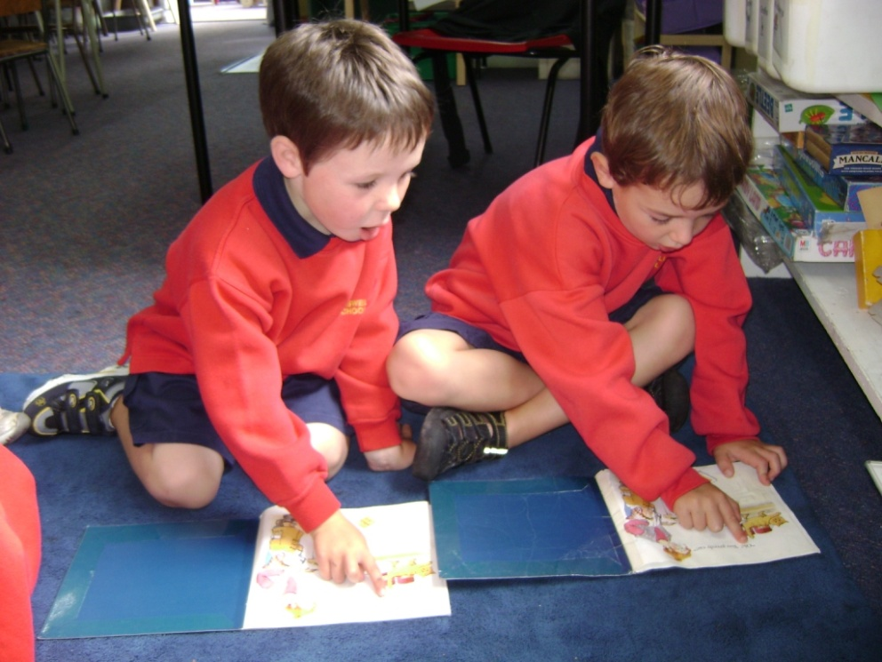

What does this tell me?
Curriculum area:
Brayden and Joe are developing some emergent reading skills. They were able to point accurately at each word while they read.
Key Competencies:
Both boys are becoming familiar with class routines at reading time and are able to make a sensible choice of activity (managing self). They had remembered their group’s reading goal and were able to practise this independently (thinking). They were able to work together at an activity (relating to others)

Where to next?
Share this learning story with the class as an example of making good independent choices at reading time.
Now that both boys can point accurately on one line texts I will set a new reading goal for them.
Parent Comment:
Have Brayden and Joe shared their new reading goal with you at home?

