

Influenza pandemic planning guide for early childhood education services, schools and tertiary organisations

Updated August 2011

Table of Contents
1. Introduction 3
2. Context 4
How is the New Zealand Government preparing for an influenza pandemic? 4
What is the Ministry of Education’s role in pandemic planning? 7
Why focus on education agencies and providers? 7
Pandemic characteristics and impact 8
Legislation 9
3. Pandemic planning 10
Emergency planning/pandemic planning 10
Pandemic manager 10
4. Pandemic is expected to arrive 11
Activation of pandemic action plan 11
Communication with your community 11
How can we protect staff, students and visitors from getting sick? 14
Managing staff and students who become ill 17
Resource: Screening Checklist [page 27] 17
Contact management 18
Staff and student travel 18
Personal protection equipment (PPE) 19
Where can we find more information? 19
5. Best practice guidelines for hand hygiene 20
6. Resources 22
A. Hand hygiene notices 23
B. Screening flowchart 26
C. Influenza staff notice 1 27
D. Influenza student notice 2 28
E. Closure notice 29
F. Suspected Influenza Notification Form 30
G. Contact list 31
H. Personal Protective Equipment (PPE) 32
I. Sample letter 1 33
J. Contact details 34
K. Sample letter 2 35
L. The difference between influenza and a common cold 36
7. Background information on influenza pandemic 37
8. Pandemic planning scenarios 39
9. Sample decision making and communication tree 41

Introduction
The Ministry of Health (MoH) is constantly updating its pandemic influenza plan and leading whole of government work to prepare for a possible pandemic in New Zealand.
Leading up to, during and post pandemic, leadership and direction will come from firstly the Ministry of Health and/or local health authorities and secondly from civil defence or local authorities.
This Planning Guide captures in one document useful information to help early childhood services centres (ECE), schools or tertiary education organisations (TEO) plan for a possible pandemic by protecting staff, students, children and education services.
The advice provided here on pandemic is generic and will need to be adapted for your ECE/School/TEO.
The Ministry of Education acknowledges that some of the material in this Planning Guide is drawn from a pandemic management plan prepared by The Shell Company of Australia Limited (“Shell”) for use in their installations in Oceania.
This Planning Guide should be used in conjunction with the Pandemic Plan for ECE/School/TEO.
Health advice will change over time as new information becomes available. Please check the Ministry of Health website for updated information.

Ministry of Education

Originally published April 2009 – Content last reviewed August 2011

Context

How is the New Zealand Government preparing for an influenza pandemic?
New Zealand has been planning for an influenza pandemic for some time. The Ministry of Health is working with the health sector and other government agencies, including the Ministry of Education, to ensure New Zealand is as prepared as possible for a potential pandemic.
The Ministry of Health has produced the intersectoral New Zealand Influenza Pandemic Action Plan that will be periodically updated to meet changing circumstances. District Health Boards have local operational plans based on the national plan.
Other Government agencies have also been actively planning for a pandemic and developing material relevant for their sector. For example, the Civil Defence Emergency Management (CDEM) Groups.
The New Zealand Influenza Pandemic Action Plan is based around “alert codes” which define the planning escalation steps for action in the event of a pandemic. Changes in alert codes will be widely publicised.
The Ministry of Health advises the potential effects of an influenza pandemic in New Zealand might be that:
- morbidity and mortality are unknown but may be very high
- full community mobilisation will be needed – all government and many community agencies are likely to be involved in the response
- health services may be unable to provide direct care (and the role of health care services may be to co-ordinate and support community mobilisation)
- periods of very high staff and student absence rates may be likely
- expect the education sector to be closed early to students and closures sustained for weeks or months, impacting on the workforce and economy.

What are the powers of Medical Officers of Health in a pandemic emergency?
Activation of the National Health Emergency Plan begins when the Ministry of Health learns of a potential national health-related emergency, such as an influenza pandemic. Medical Officers of Health will be working as part of each district’s and region’s health response coordination team and have wide ranging powers designed to prevent the outbreak or spread of any infectious disease. These powers include the ability to:
- require people to submit themselves for medical examination
- require people, places, buildings, ships, animals, and things to be isolated, quarantined, or disinfected
- forbid persons, ships, animals, or things to be brought to any (air or sea) port or place in the health district from any port or place supposed to be infected
- forbid persons to leave a place or area until they have been medically examined and found to be free from infectious disease
- require theatres, churches, bars, clubs and other public gathering places to be closed
- prohibit the attendance of students under the age of 16 years in schools, Sunday schools, and other public places within the district
- have infected animals destroyed.
How should ECE/Schools/TEOs liaise with health authorities?
- The Chief Medical Officer of Health (Ministry of Health) or local Medical Officers of Health, or another designated officer attached to the public health service would provide leadership, direction and guidance as to what to do – remain open, close or reopen.
- It is important to know how to make contacts with your local District Health Board (DHB) or Public Health Service so that you can obtain advice on local circumstances during a pandemic to inform your actions.
- Only if possible, adopt a single point of contact through which local advice to ECE/Schools/TEOs can flow. Groupings such as established clusters, principals’ associations and other sector organisations could help play a significant role. Now is the time to agree how you will group together for this purpose in your area.
What does closure mean?
Closing ECE/Schools/TEOs to students would not necessarily mean that facilities would be closed in a quarantine sense. Staff may still go to work, work remotely, or carry out ‘alternative duties’ for other agencies with their board’s pre-approval. Facilities may also be used for alternative purposes such as Community Based Assessment Centres (CBAC).
However, during a pandemic the Chief Medical Officer of Health (Ministry of Health) or local Medical Officers of Health, or another designated officer attached to the public health service would provide leadership, direction and guidance as to what to do – remain open, close or reopen.

What does the Legislation say?
The Education (Early Childhood Centres) Regulations 1998:
- Require licensees to take reasonable steps to exclude children or staff if they have an infectious disease specified in Schedule 2 of the Health (Infectious and Notifiable Diseases) Regulations 1966;
- Provide that the health regulations will apply to early childhood centres, in the same way but with the necessary modifications, as they apply to schools;
- Enable the Secretary for Education to suspend a centre’s licence (and therefore stop it from operating) if reasonable action is not taken to prevent children from coming into contact with a person suffering from an infectious disease. This discretion is rarely exercised in normal circumstances, but could be used in the event of a pandemic. It is more likely, however, that the Medical Officer of Health would exercise powers under the Health Act 1956 to restrict the attendance at early childhood centres as necessary.
The Education Act 1989 gives principals and boards powers to exclude particular students and staff or to close their school in certain circumstances:
- Section 19 provides that a principal may exclude a student who may have a communicable disease (communicable diseases are specified in the Schedule to the Act. Highly Pathogenic Avian Influenza or ‘bird flu’ (HPAI subtype H5N1) was added on 12 February 2004. In practice, schools would generally proceed subject to advice received from health authorities.
- Section 65E provides that a board may close a school in an emergency such as an epidemic.
- The Health (Infectious and Notifiable Diseases) Regulations place duties on schools, teachers and parents in the case of a pandemic.
- Regulation 14 provides that schools must exclude teachers and students who have an infectious disease.
Tertiary organisations - there is no specific power in the education legislation authorising the closure of tertiary institutions. That power lies with the Ministry of Health under the Health Act 1956.
However, any decision by the board chair, chief executive, principal or management to close the ECE/School/TEO should be based on advice or direction from health authorities.

What is the Ministry of Education’s role in pandemic planning?
The Ministry of Education leads pandemic planning for the education sector and has information and resources available on the Ministry of Education website to assist with contingency planning.

Why focus on education agencies and providers?
Size of the sector
More than a quarter of New Zealanders are directly involved in the combined education sectors. Because a key response to pandemic influenza will be to minimise social gatherings, education providers need to be prepared for enforced and sustained regional or national closures of their facilities to students by health authorities. Pandemic modelling strongly suggests that education environments – especially those dealing with young people – provide a very fertile ground for spreading viruses.
At this planning stage, ECE/Schools/TEOs can play a key role in contributing to cultural change around good personal hygiene practices (such as cough and sneeze etiquette, hand washing and drying etc).
Need for cohesive response
Boards, Chief Executives, Boards of trustees, principals and management will need to take direction from health authorities regarding any enforced closures. Health authorities will ensure they use their powers of closure in ways that would be helpful to a cohesive national response. For example, cluster control of a pandemic in Auckland may not trigger closures elsewhere in the country.
An important consideration is that the types of response to a pandemic as it progresses will change, and circumstances will vary in different parts of the country.

Role of education sector in recovery
Education agencies and providers will be central to social recovery when a pandemic abates. Planning should anticipate psychosocial pressures at this stage.

Pandemic characteristics and impact
A pandemic has unique characteristics when compared with a more “typical” disaster. For example:
- Widespread impact
The impact of a pandemic would likely be widespread, even nation-wide, not localised to a single area and there may be little outside assistance. Many business continuity plans assume some part of an organisation is unaffected and can take up the required capacity.
- Not a physical disaster
A pandemic is not a physical disaster. It has some unique characteristics that require measures to limit contact, restrict movement, introduce quarantine and ban public gatherings.
- Duration
A pandemic would not be a short, sharp event leading immediately to the start of a recovery stage. A pandemic emergency may last several weeks or months. Plans need to take this into account.
- Notice
Some advance warning is likely if a pandemic develops overseas, but that warning period may be very short. Should pandemic influenza spread within New Zealand the education sector would most probably be one of the first sectors to be closed and closures sustained
- Primary effect is on staffing levels
Unlike natural disasters where disruption to infrastructure and service delivery is likely to be related to hardware, a pandemic is more of a threat to staff. Employers will need to plan for the scenario of up to 50% staff absences at the height of a severe pandemic. Ministry of Health modelling shows that two weeks leave is the average amount of leave required for sickness and recovery of a staff member. Overall, a pandemic wave may last about eight weeks, though the pandemic may come in several waves of varying severity over time.
Staff absences can be expected for many reasons, including:

- illness or incapacity (suspected or actual)
- their need to stay at home to care for sick dependents
- they may feel safer working from home (for example, to keep out of crowded places such as public transport – public transport may cease)
- some people may be assigned to ‘alternative duties’ for their employer or another agency (such as health or welfare roles)
- others may need to stay at home to look after pre-school and school-aged students (as early childhood education services and schools may be closed).
A pandemic may have other impacts on services, for example:
- supplies of materials needed for ongoing activity may be disrupted when, for example, supplies are normally imported across borders that have been closed or are being tightly controlled
- services from sub-contractors may be affected (impacting maintenance of key equipment and this issue merits close planning attention)
- demand for infrastructure services may be affected – demand for some services may increase (internet access is a possible example); while demand for others may fall (for example, types of travel activity may reduce)
- education delivery is not expected to continue during a pandemic. In a pandemic early and enforced sustained closure of education facilities to children and students is the most likely scenario.

Legislation
Compliance with the Health and Safety in Employment Act 1992
In addition to requirements under the Civil Defence Emergency Management Act, pandemic planning will help ECE/Schools/TEOs ensure they meet their obligations under the Health and Safety in Employment Act, including:
- Section 6: All practicable steps
“Every employer shall take all practicable steps to ensure the safety of employees while at work; and in particular shall take all practicable steps to:
- provide and maintain for employees a safe working environment
- provide and maintain for employees while they are at work facilities for their safety and health...”
- Section 28: Employees may refuse to perform work likely to cause serious harm
“An employee may refuse to do work if the employee believes that the work that the employee is required to perform is likely to cause serious harm to him or her....”

Pandemic planning
The following information is generic and will need to be adapted to meet your specific needs and circumstances. Most advice given in this section relates to the “plan for it” or “stamp it out” stages of a pandemic. In the “stamp it out” stage, ECE/Schools/TEOs in affected areas will be closed to students/children.
This section also applies to those outside affected areas that may be expected to maintain “education as usual”.

Emergency planning/pandemic planning
Ensure you have an emergency plan in place to meet health and safety requirements.
It is not possible to predict how long a pandemic may last. There could be more than one wave of infection during a pandemic period. Each wave could typically last about eight weeks.
Continuity planning for a pandemic should include:
- identification of essential activities (and the core people and skills to keep them running), ensuring these are backed-up with alternative arrangements
- minimising the risk of infection for staff and students.

Pandemic manager
The “pandemic manager” is likely to be the principal or a member of the management team, or a small team working together. Some tasks the “pandemic manager” may perform include:
- Establishing a system to monitor staff who are ill or suspected of being ill, including contacting staff who are unexpectedly absent from work – has their doctor been notified of their illness? Have they been in contact with anyone? Have “contact” issues been addressed? Is someone able to care for them?
- Ensuring adequate supplies of tissues, medical and hand hygiene products, cleaning supplies and masks. It may be difficult to purchase such products once a pandemic begins.
- The above two points are particularly important during the “stamp it out” stage when you may still be required to remain open but vigilant.

Pandemic is expected to arrive

Activation of pandemic action plan
The Ministry of Health will widely publicise any changes to the “alert codes”, and may signal the need to activate pandemic and continuity plans. The Ministry of Education will keep regional and local Ministry offices, education agencies and education sector groups informed of these changes. You will most likely find out about changes to “alert codes” via media, Ministry of Education, sector representative group or your cluster point of contact.
Leadership and direction will come centrally from the Ministry of Health or health local authorities or via the Ministry of Education. We expect widespread and immediate closures of educational facilities.

Communication with your community
It is likely there will be anxiety leading up to and during a pandemic and this is likely to contribute to increased absence and/or increased stress to the board, managers, staff, parents/whānau and students. Ways to manage this might be to:
- Communicate early the possibility of a pandemic and your preparedness to manage it – to your board, staff, students, parents and whānau. Ministry of Health influenza advice might be useful.
- Discuss with staff possible health and safety issues, and leave arrangements for them if they are ill or need to look after dependents.
- Have a comprehensive plan in place which is clearly communicated to your board, staff, students, parents and whānau. Ensure that communications management during the pandemic is part of the plan.
- In activating your plan, provide clear, timely and pro-active communications to your board, staff, students, parents and whānau explaining how your are managing the situation.
- Establish a “communications tree” to circulate important messages. Consider how you might maintain communication with:
- board, staff, student, parents and whānau
- other ECE/Schools/TEOs in your area/cluster
- relevant agencies and community support networks
- key suppliers and contractors.
How will essential activities be maintained?
In the event of a pandemic it is important that people with core skills are available to keep essential parts of your ECE/School/TEO functioning even if it has been closed to students. Some schools/TEOs may have to keep a hostel open to cater for students who are unable to return home. The following points are designed to help you plan for this type of contingency:
Identify core people and core skills
Issues you may wish to consider include:
- What are the “essential” parts of your operation?
- Who are the key people required to keep these essential parts running?
- What are the core skills required to keep them running?
- Is there sufficient back-up for people and skills if there is a high level of absence? Are there other resources (such as volunteers, retirees) that could be drawn on if necessary? Is it possible to co-ordinate/operate this provision remotely, using telephone and email?
- Who are the key people required to manage the pandemic contingency plan?
- Do you have any systems which rely on periodic physical intervention by key individuals to keep them going? How long would the system last without attention?

Once the core people and skills are identified, ensure that they are aware of their position and how they will be managed in the event of a pandemic. Consider strategies for minimising the possibility that they become ill with influenza, by working from home or other social distancing measures.
You may wish to have non essential staff indicate their willingness to carry out “alternative duties” such as tracing contacts of infected students and/or staff or assisting another agency (for example, in health or welfare roles) during the Code Red phase to help the community manage and recover from the pandemic.
Planning for absence
Issues you may wish to consider include:
- What are critical staff numbers and skills required to keep essential parts of the ECE/School/TEO running? At what level of staff absence does “business”, such as administration, stop? What arrangements need to be made to minimise risks to staff?
- Who would have appropriate delegation to make the decision to shut activity down when absence rates threaten safe continuation of core operations?
- Pandemic influenza may affect regions of New Zealand and the world differently in terms of timing, severity and duration. Some regions may be hit earlier, longer or harder. Restrictions on movement of people may be imposed and many staff activities may therefore be difficult to maintain. It may be a question of dispersing the knowledge and skills through appropriate, planned staff training programmes.
Knowledge management
Key operating and emergency management information will need to be stored in known, accessible and shared locations. Preferably these should not rely on electronic storage only, and be backed up off site.
Communication links
Build communication links with key contacts, relevant agencies and community support networks:
- Staff, students, parents and whānau
- Ministry of Education regional or local office
- New Zealand School Trustees Association (NZSTA): phone 0800 STAHELP or email helpdesk@nzsta.org.nz
- Other ECE/Schools/TEOs in your cluster/area
- Your doctor, if possible
- Child Youth and Family (CYF) local offices
- Welfare Advisory Group (WAG).
Local government Civil Defence Emergency Management (CDEM) groups and Regional Civil Defence Emergency Management (CDEM) groups are consortia of local authorities, emergency services (police, fire, health), lifeline utilities and others working together within regional boundaries - administered by regional councils.
How might shortages of supplies affect you?
Shortages of supplies may occur because of increased demand during the pandemic (for example, cleaning supplies, food for hostels). Pandemic planning should consider the need for ensuring adequate essential supplies.

How can we protect staff, students and visitors from getting sick?
Although we expect widespread centrally coordinated closures during a pandemic event, the following section has been developed to enable you to plan and manage remaining open during localised events like annual influenza.
Your pandemic plan should consider how to minimise illness among staff, students and visitors and include:
- Restricting entry of people with influenza symptoms.
- Practising good personal hygiene and workplace cleaning habits.
- Increasing social distancing (by minimising close physical contact and avoiding situations where you or the students may come into contact with infected people, such as outings to enclosed places). Though social distancing is a key strategy during a pandemic, this would be a challenge for educators of very young students such as 5-6 year olds). As long as closure has not been directed, take a common sense approach on how to handle appropriate social distancing between students and students, and students and staff.
- Managing staff and students who become ill.
- Managing any staff and students who are travelling overseas or who have recently returned from affected countries.

Table 1 - Summary of Influenza Protection Measures

Protection measure | Where applicable
Hand hygiene, cough etiquette, ventilation | Everyone, all the time
Health and safety policies | Everyone, all the time
Social distancing | Everyone, whenever practical stay at least one metre away from other people.
Protective barriers | In situations where regular work practice requires unavoidable, relatively close contact with the public, for example, reception areas.
Disposable surgical mask | Sick people coughing and sneezing  Staff having close contact with suspected infected people, for example, in sick bay caring for the sick (this includes first aiders)  Also as a possible adjunct to protective barriers.
Disposable particulate respirator masks, eye protection, gloves, gowns, aprons | Health care workers participating directly in close contact patient care when there is a high risk of contact with respiratory secretions, particularly via aerosols (mostly inpatient settings). Unlikely to be necessary in schools.
Restrict workplace entry of people with influenza symptoms
On declaration of Code Red, consider putting up notices at all entry points, advising people not to enter if they have influenza symptoms.
Children or students who are unwell should remain at home. Staff, parents and whānau should be advised not to come in when they are feeling unwell, or if they are exhibiting any influenza symptoms.
Use your normal communication methods to ensure all staff, parents and whānau receive notices. You may also provide them with information about how to stay well during a pandemic, such as the Ministry of Health advice.
In your pandemic planning establish a process for ensuring that ill students and staff have completed any required quarantine period and are healthy before allowing them to return.
Students and staff who have recovered from the pandemic influenza are unlikely to be re-infected (they will have natural immunity) and should be encouraged to return as soon as they are well and, for students, the school has re-opened to them.
Personal hygiene
You can make a major contribution to national preparedness and safety through personal hygiene education programmes. Personal hygiene measures should be reinforced as a key way to minimise influenza transmission:
- Cover nose and mouth when sneezing and coughing (preferably with a disposable single use tissue).
- Immediately dispose of used tissues.
- Adopt good hand washing and drying practices, particularly after coughing, sneezing or using tissues.
- Keep hands away from the mucous membranes of the eyes, mouth, and nose.
- Ensure that adequate supplies of hand hygiene products are available. This is a high planning priority as there may be shortages of liquid soap and paper towels.
Communicate hand and personal hygiene information to staff and visitors:
- Hygiene notices should be posted in all workplace entrances, washrooms, hand washing stations and public areas. The notice examples provided (see the Resources section) could be simplified to make them appropriate for student areas.
- Use brochures, newsletters, global emails, notice boards, and information included with payslips, informing staff, whānau and students of the importance of hand hygiene and workplace cleaning at all times, especially during a pandemic.
Cleaning
During a pandemic ECE/Schools/TEOs will be closed, but you may need to clean thoroughly to destroy any virus. This applies particularly to hard surfaces (for example, sinks, handles, railings, objects and counters). Influenza viruses may live up to two days on hard surfaces.
Influenza viruses are inactivated by alcohol and by chlorine. Cleaning of surfaces with a neutral detergent followed by a disinfectant solution is recommended. Surfaces that are frequently touched with hands should be cleaned often, preferably daily. Information about the appropriate choice and concentration of disinfectants can be found on the Ministry of Health website.
- Hygiene practices should be elevated in a pandemic to an even higher level than usual.
- Remind staff and students not to share cups, dishes and cutlery; and ensure these items are thoroughly washed with soap and hot water after use.
- Remove books, magazines and papers from common areas.
- Consider ways of cleaning and/or restricting communal use of some play, physical education equipment and office equipment.
- When a person with suspected influenza is identified and has left, it is important that their work area or office and any other known places they have been are thoroughly cleaned and disinfected.
- Planning should identify the basic hygiene practices (including hand hygiene) to be followed by cleaners, protocols for the use of personal protection equipment (if recommended by the Ministry of Health), and methods for waste disposal.
Ventilation
The Ministry of Health and the Department of Labour recommend all internal spaces should be well ventilated, preferably by fresh air via opening windows, or by properly designed and maintained air-conditioning systems.
Social distancing
In primary schools social distancing may be difficult to achieve, but any raising of awareness or any level of compliance will be useful.
Social distancing is a strategy to protect staff and students during a pandemic by minimising their contact with others. Events involving large gatherings should be avoided, whether inside or outside. A distance of at least one metre should be maintained between people wherever practical. The Ministry of Health has the following suggestions for minimising contact, but you will need to decide which of these measures are practicable:
- Where possible avoid meeting people face-to-face – use the telephone, video conferencing and the internet to conduct business as much as possible – even when participants are in the same building.
- Avoid any unnecessary travel and cancel or postpone non-essential meetings, gatherings, workshops or training sessions.
- Avoid public transport: walk, cycle, drive a car or go early or late to avoid rush hour crowding on public transport.
- Bring lunch and eat away from others (avoid the staffroom and crowded cafes). Introduce staggered lunchtimes and morning teas to reduce numbers in the staffroom. Consider how the school cafeteria or tuck shop should be managed.
- Do not congregate in staffrooms or other areas where people socialise. Do what needs to be done and then leave the area.
- If a face-to-face meeting with people is unavoidable, minimise the meeting time, choose a large meeting room and sit at least one metre away from each other if possible. Avoid shaking hands or hugging. Consider holding meetings via conference call or outside.
- Set up systems where families and staff can request information via phone, email or fax and have information ready for fast pick-up or delivery.
- Encourage students and staff to avoid recreational or other leisure classes or meetings where they might come into contact with infectious people.

Managing staff and students who become ill
Your pandemic plan should indicate how you will manage staff and students who become ill. In the event of a pandemic, it is recommended that you check the Ministry of Health website for the latest advice. If a person feels ill or someone observes that another person is exhibiting symptoms of influenza, they are to contact the “pandemic manager”, by telephone if possible.

Resource: Screening Checklist [page 27]

Contact management
Contact definition
The Ministry of Health defines pandemic influenza contacts as people who, during the infectious period of a suspected or confirmed case, were:
- household members of the case
- close workplace contacts of the case, including people sharing an office or cubicle area or whose work brought them into close physical proximity (sitting within 1 metre for at least 15 minutes) with the case, but not people who share general office space
- members of the case’s class or child care group (up to and including tertiary education) with whom most of the day is spent and who spent at least 15 minutes within 1 metre of the case; this definition could include the teacher or child care supervisor
- identified by the case as being in close physical contact (eg hugging, kissing, sitting within 1 metre for at least 15 minutes) with the case.
People who have not been in close proximity nor shared a confined airspace with a sick person within four days of that person developing symptoms, are not considered to be contacts.
Note that the contact definition may change, depending on the nature of the pandemic virus when a pandemic occurs. Up to date contact definitions will be placed on the Ministry of Health and Ministry of Education web sites.

Contact management mandated by law
Under the Health Act 1956, both highly pathogenic avian influenza (HPAI) and influenza are classed as infectious diseases. HPAI is also a notifiable disease, meaning that some additional provisions of the Health Act apply to it, over and above the provisions that apply to influenza. To reduce the risk of further infection contacts will be expected to stay at home and avoid contact with others for a recommended period. This period will be set by health officials and is not at the discretion of employers.
In any circumstance, boards, chief executives, principals and managers should urge sick staff members with influenza-like symptoms to return home immediately and contact a health professional. For sick students this will need to be done through parents/whānau.
As indicated in the previous section, it is helpful for boards of trustees and principals to:
- identify contacts (once anyone from the school is suspected to be infected)
- advise contacts in person that they have been in contact with a person suspected of having influenza
- ask contacts to go home and stay at home until advised otherwise.

Staff and student travel
The Ministry of Foreign Affairs and Trade and Ministry of Health will publish appropriate travel advisories for people travelling to other countries infected by the pandemic. They will also provide advice for government staff and other New Zealanders in infected areas.
Once a pandemic is recognised, our border may immediately be closed to all incoming passengers and aircrew, possibly for several days.
It is likely that quarantine measures will be set up before passenger movements resume. It is possible that all incoming people will be required to complete at least eight days quarantine before being allowed past the border. These arrangements may change so check relevant websites at the time.
If your staff and/or students travel overseas your plan will need to consider their management in the event of a pandemic. Similarly, students from overseas or New Zealand students returning to New Zealand will need consideration in the event of a pandemic. For example, on declaration of a pandemic, if any staff or students have recently (within the last four or five days) visited countries known to be affected by the disease, you should:
- Advise the person (or the parents/whānau for a student) not to attend ECE/School/TEO for the duration specified by Ministry of Health for the disease.
- Ask them to follow instructions on Ministry of Health website for self-checking for influenza symptoms, which may include advice to telephone (rather than visit) their medical centre to seek advice immediately if symptoms occur.
- Check on the staff member or student during his or her absence.
- Establish a process for ensuring that the staff member or student has completed the appropriate quarantine and is healthy before allowing them to return.

Personal protection equipment (PPE)
In the event of a pandemic refer to Ministry of Health website for the latest information.
Using masks
People with influenza symptoms should use a disposable surgical mask to help prevent exposing others to their sneezes and coughs. Used masks must be disposed of as soon as they become moist or after any cough or sneeze, and hands must be thoroughly washed and dried after the used mask has been discarded.
Protective barriers
Protective barriers in the form of perspex or glass may provide useful protection for people such as front-reception staff, whose duties require them to have frequent face-to-face contact with members of the public where social distancing is either not possible or not practical.

Where can we find more information?
- Visit the Ministry of Health website – for background information about pandemic influenza, National Health Emergency Plan, pandemic preparedness, planning, and latest updates.

Best practice guidelines for hand hygiene
Effective hand washing and drying routines are a primary means of reducing infections in students and staff.

Many disease causing virus and bacteria are carried on hands and can be passed from person to person through direct contact with the person’s hands or though objects or food that the person has touched.

Students should be encouraged to take responsibility for their own hand washing and drying but to do so they need a supportive environment.

Recommended technique for good hand hygiene practice
- Wet hands, preferably with warm water and apply liquid soap
- Rub hands vigorously together and rub all areas
- Wash for 20 seconds (about the same time as it takes to sing Happy Birthday)
- Rinse well and dry hands thoroughly, the following examples are considered thorough:
  - 20 seconds by paper towel (2 towels 10 seconds on each towel)
  - 20 seconds by clean roller towel
  - 45 seconds by air dryer
  - 10 seconds by towel followed by 20 seconds by air dryer
Times when hands should be washed
- After coughing or sneezing (when the hands have been used to cover the mouth or nose)
- After using the toilet or after handling animals
- Before, during and after the preparation of food
- When hands are dirty
- More often if someone is sick
Rationale and tips for use of:
Liquid soap
- Lowers the likelihood of the transfer of infection from person to person.
- Wall mounted dispensers are preferable to hand held dispensers.
- Pump action dispensers help reduce soap wastage.
- Research the best soap and dispenser deal, getting a free dispenser from a supplier might be a good option, but beware of deals that lock you into higher priced bulk soap.
Paper towels
- Lower the likelihood of the transfer of infection from person to person.
- To make these more economical, half-sized paper towels are available that can be used with standard dispensers.
- Research the best towel and dispenser deal.
Roller towels
- Ensure these are the type that roll and retract once used to avoid spread of infection.
- Younger students may find these difficult to use.
Air dryers
- Hands must be dried thoroughly to stop the spread of infection (takes approx 45 seconds).
- Younger students may find air dryers frightening to use.
Warm water
  - Warm water is preferable to cold water.
  - Providing warm water improves compliance of people washing their hands at all. What proportion of students will put their hands under ice-cold water in the winter?
  - If warm water is supplied, it must not exceed a temperature of 40ºC.
Wash troughs
- A long stainless steel wash trough has several advantages over basins that make them economic to install and maintain.
- A wash trough with enough space for five students to use only takes the space of three wash hand basins.
- By having temperature controlled warm water (40ºC maximum), you only need warm water taps, not cold taps. This means for example, five taps for five students instead of six taps for three students.
- A wash trough only needs one waste outlet. Three basins need three outlets.
- Wash troughs are easier to clean than multiple hand basins.

The Ministry of Education has worked with the Ministry of Health to produce these best practice guidelines.

Resources
The following pages have sample notices and templates for you to use or adapt, including:

- Hand hygiene notices:
  - Protecting yourself and others
  - Hand hygiene with soap and water
  - Hand hygiene with alcohol-based hand sanitizer
- Screening flowchart for detection and management of suspected pandemic influenza cases
- Influenza staff notice 1
- Influenza student notice 2
- Closure notice
- Suspected influenza case
- Contact list
- Personal Protective Equipment (PPE) guidelines and suggested pandemic supplies
- Sample letter 1
- Contact details
- Sample letter 2
- The difference between influenza and a common cold

A. Hand hygiene notices

PROTECTING YOURSELF AND OTHERS AGAINST RESPIRATORY ILLNESS

HANDWASHING IS THE MOST IMPORTANT THING YOU CAN DO TO PROTECT YOURSELF

- Cover your nose and mouth when coughing or sneezing

- Use a tissue and dispose of this once used

- Always wash hands after coughing and sneezing or disposing of tissues

- Keep your hands away from your mouth, nose and eyes.

- Avoid contact with individuals at risk (eg, people with underlying or chronic illnesses such as immune suppression or lung disease) until the influenza-like symptoms have resolved.

- Avoid contact with people who have influenza-like symptoms.

- Ask students to use a tissue and cover their nose and mouth when coughing or sneezing and to wash and dry their hands afterwards.

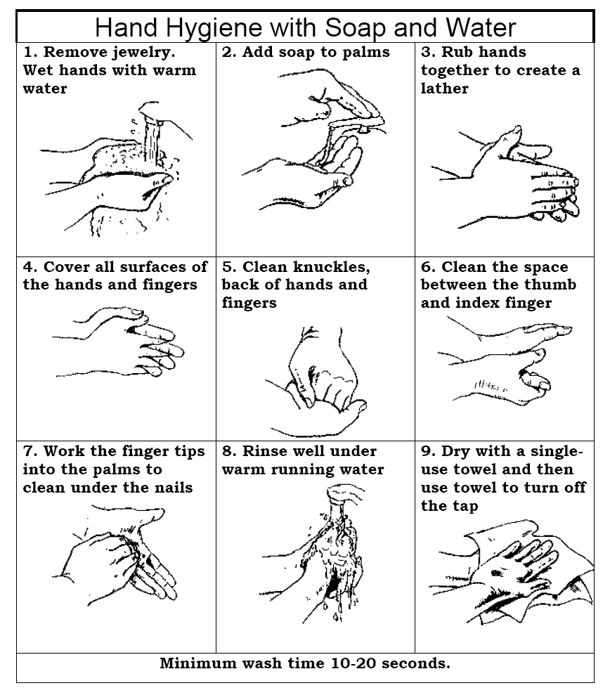

Source: Vancouver Coastal Health’s Regional Pandemic Influenza Response Plan

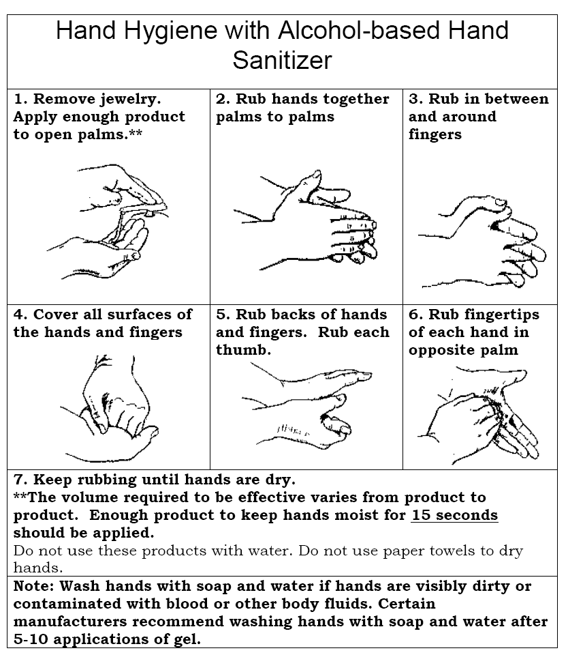

Source: Vancouver Coastal Health’s Regional Pandemic Influenza Response Plan

B. Screening flowchart

For detection and management of suspected pandemic influenza cases

Process
- Your school’s influenza manager receives a call from a person suspecting they may have influenza, or from a staff member who has noticed a child who may be ill.
- Avoid contact with the sick person if possible and manage the process over the telephone.
- For someone at the school who is ill, follow the flowchart below:

Unlikely to be influenza.
Reassure
Advise them or the parents/whānau to visit their doctor.
Obtain a surgical mask for the person ill at school and organise for them to leave school immediately. Suggest they or their family call their doctor by telephone to advise that they have been in contact with a suspected influenza case.

Arrange for cleaning of the area where they have been.
Advise contacts that they have been in contact with suspect case.
Ask contacts to go home and to stay there until advised otherwise.
No symptoms, as described above
Assess whether the person or child has any of the following:
High fever (or feel feverish and hot)
Headache, fatigue and weakness
Sore throat, cough, chest discomfort, difficulty in breathing
Muscle aches and pains.
Been overseas recently to an affected country
Been in contact with someone diagnosed with influenza.

Been in contact with someone diagnosed with influenza.
Person unwell. May be considered as possible case of influenza.
Fill in the suspected influenza Notification Form. Take names of contacts (those who have been within one metre of them or in an enclosed place for more than 60 minutes).

Yes, has two or more symptoms described above, and been overseas OR in contact with some diagnosed with influenza

Yes, two or more of symptoms, as described above

C. Influenza staff notice 1

INFLUENZA NOTIFICATION

Influenza is a contagious disease.
There is currently an increase in the numbers of people in New Zealand with influenza. To prevent the spread of influenza here:

DO NOT ENTER if you have:
- chills, shivering and a fever (temperature above 38ºC)
- onset muscle aches and pains
- sore throat
- dry cough
- trouble breathing
- sneezing
- stuffy or runny nose
- tiredness

If you start to feel ill at school or are showing any of the symptoms listed above,
DO NOT leave your area.

Call the influenza manager

…………………………………… Phone ext………

D. Influenza student notice 2

INFLUENZA NOTIFICATION

Influenza is a contagious disease.
There is currently an increase in the numbers of people in New Zealand with influenza.
To prevent the spread of influenza in this school, you must tell your teacher if you have any of the following flu symptoms:

- chills, shivering and a fever
- onset of muscle aches and pains
- sore throat
- dry cough
- trouble breathing
- sneezing
- stuffy or runny nose
- tiredness

E. Closure notice

SCHOOL CLOSED

DUE TO THE INFLUENZA PANDEMIC,

THIS SCHOOL IS CLOSED UNTIL FURTHER NOTICE

DO NOT ENTER

Unless, you have to collect a child, please precede to_________________________
_________________________________

For urgent enquiries, contact

_________________________

F. Suspected Influenza Notification Form

Details of Affected Staff/Students

Name: | Site: | Location of isolation:
Job title: | Nationality if visitor to site: | Date of birth:  (optional)
Address:

Telephone no:
(W) (H) (M)

Symptoms noticed:

Fever Body aches
Headache Fatigue
Dry cough Others Details:
Cold

Time of fever on-set:

Time of isolation:

Travel history over the past eight days:

Countries visited

Flights taken:

Where referred:

Contact List (See separate page)

Where referred:

Contact List (See separate page)

Details of Reporter

Name:

Job title:

Telephone no:
(W) (H) (M)

G. Contact list
The Ministry of Health currently defines pandemic influenza contacts as:
Contacts include people who, during the infectious period of a suspected or confirmed case, were:
- household members of the case
- close workplace contacts of the case, including people sharing an office or cubicle area or whose work brought them into close physical proximity (sitting within 1 metre for at least 15 minutes) with the case, but not people who share general office space
- members of the case’s class or child care group (up to and including tertiary education) with whom most of the day is spent and who spent at least 15 minutes within 1 metre of the case; this definition could include the teacher or child care supervisor
- identified by the case as being in close physical contact (eg hugging, kissing, sitting within 1 metre for at least 15 minutes) with the case.
Note that the contact definition may change, depending on the nature of the pandemic virus when a pandemic occurs. Up to date contact definitions will be placed on the Ministry of Health and Ministry of Education web sites.

Retain this list and provide to the Medical Officer of Health or his/her designated officer on request.

People the affected person has interacted with since displaying symptoms
Name | Email | Telephone number | Address

H. Personal Protective Equipment (PPE)

Guidelines
The Department of Labour and Ministry of Health websites have guidelines which may help you decide on appropriate personal protective equipment to protect staff and children in your school.

Suggested list
The following generic list approved by the Department of Labour can be used as a starting point for your pandemic preparations. It is an 'over-the-top' list to cover all contingencies, so you will need to adapt it to your school’s needs and requirements.

Emergency Pandemic Supplies
Suggested list - stock pile supplies for one to two weeks
Breathing mask (box 50) 3 per person per day
Eye goggles (1 per staff dealing closely with sick person)
Latex / non-latex gloves (100s) 10 per staff per day
Disposable apron for staff (1 per staff per day)
Tissues (box 200) 3 boxes per person per week
Paracetamol (box 20) 1 box per adult per week;
Paracetamol (suspension) 50mls per child per week
Disinfectant (2 litres) 1 bottle per 15 people per day
Janola (2 litres) 1 bottle per 15 people per day
Cleaning fluid (1 litre) 1 bottle per 15 people per day
Toilet paper minimum 2 rolls per person per week
Paper towels (2 packets per person over 3 weeks)
Carton of Chux Cloths
Liquid soap/alcohol wash (1 litre)

You will need to consider staff education and training in the use of personal protection equipment:
- preventative guidelines
- staff awareness
- documentation.
Pandemic Stage 1

I. Sample letter 1

Letter to parents/caregivers: introduction to pandemic planning

Dear Parents / Caregivers

Most of you will be aware that we are starting to see signs of a possible increase in the ‘[name]’ virus. International health experts are concerned that the virus could mutate to pass easily between humans, leading to a global pandemic.

The government is preparing plans to protect the country from a possible influenza pandemic.

Our ECE/School/TEO has an emergency management plan that covers most emergencies, such as fire and earthquake. Using resources provided by the Ministry of Education, we are now updating our emergency management plan to include plans for coping with a pandemic.

We will keep you informed as our pandemic plan develops. Meanwhile, you can reduce the risk of your child catching influenza by:

- Teaching your child(ren) the importance of hand washing – especially before meals and after toileting.
- Teaching your child(ren) to use a disposable tissue when coughing or sneezing.
- Keeping your child(ren) at home if they have the flu.

An important part of emergency planning is ensuring we have up-to-date contact details for all students and staff. Please ensure that you complete and return the attached form. Your personal details will not be used for any other purpose other than in the context of emergency management.

If you have any questions or concerns at this stage, please contact me directly.

Yours sincerely

________________
Principal/Manager

J. Contact details
Please take time to fill out this form with up-to-date contact details for you as parents/caregivers of your child (or children) at school. Please also provide two local emergency contacts of people your child knows (eg, family/friends) who could take care of your child in an emergency:

Date: ___________________________
Family name: ____________________________________
Name(s) of child (ren): ______________________________________________________
__________________________________________________________________________
- Parent/caregiver:_______________________________________
Home phone: _______________________
Work phone: ________________________Mobile phone: ____________________

- Parent/caregiver______________________________________
Home phone:_______________________
Work phone:________________________ Mobile phone:_____________________
- First emergency local contact (eg, friend or family member):
Name__________________________________________
Home phone: _______________________
Work phone: ________________________Mobile phone: ____________________
- Second emergency local contact (eg, friend or family member):
Name__________________________________________
Home phone: _______________________
Work phone: ________________________Mobile phone: ____________________

K. Sample letter 2
Pandemic Stage 2

Dear Parents / Caregivers

The government has announced that New Zealand is stepping up its pandemic influenza response plans. This means that the situation overseas has changed and New Zealand’s borders have been tightened in an attempt to stop the virus getting here.

We are talking with health and civil defence officials and we have been advised that there is no reason for alarm. We will remain open until further notice. Our own pandemic plans mean that we have systems in place to help us cope if anything changes.

The most important thing you can do as parents and caregivers is reinforce healthy messages:

- Teach your children the importance of hand washing and drying – especially before meals and after toileting.
- Teach your children to use a disposable tissue when coughing or sneezing.

We ask that all children or students showing flu like symptoms be kept home until checked and okayed by a doctor or nurse to return. The symptoms of influenza and how they differ from common cold symptom are included with this letter.

We are updating our emergency contact details for all students and staff. Please complete the attached form and return it to your child’s/student’s classroom teacher.

The board of trustees and I are working closely with staff to ensure that all students are kept as safe as possible.

If you have any questions or concerns please contact me directly. Thank you.

Yours sincerely

________________
Principal/Manager

L. The difference between influenza and a common cold

SYMPTOM | INFLUENZA | COMMON COLD
Fever | Usual, sudden onset 38º-40º and lasts 3-4 days. | Rare
Headache | Usual and can be severe | Rare
Aches and pains | Usual and can be severe | Rare
Fatigue and weakness | Usual and can last 2-3 weeks or more after the acute illness | Sometimes, but mild
Debilitating fatigue | Usual, early onset can be severe | Rare
Nausea, vomiting, diarrhoea | In children over 5 years | Rare
Watering of the eyes | Rare | Usual
Runny, stuffy nose | Rare | Usual
Sneezing | Rare in early stages | Usual
Sore throat | Usual | Usual
Chest discomfort | Usual and can be severe | Sometimes, but mild to moderate
Complications | Respiratory failure; can worsen a current chronic condition; can be life threatening | Congestion or ear-ache
Fatalities | Well recognised | Not reported
Prevention | Influenza vaccine; frequent hand-washing; cover your cough | Frequent hand-washing, cover your cough

Background information on influenza pandemic
What is an influenza pandemic?
Influenza pandemics are characterised by the spread of a novel type of influenza virus to many parts of the world, causing unusually high morbidity (illness) and mortality (deaths) for perhaps two to three years. Most people do not have immunity to the virus and therefore are susceptible to influenza infection. A pandemic can overwhelm the resources of a society due to the exceptional number of those affected.
A pandemic may occur as a result of the emergence of a new viral sub-type with the capacity to spread efficiently from human to human.
Where can we find international information updates?
The World Health Organisation website provides updates on the global occurrence of avian influenza, risks to humans, vaccine and anti-viral developments. It also provides useful background information about the nature and characteristics of avian influenza and past pandemics.
The New Zealand Ministry of Health also provides much relevant information.
What are the symptoms of influenza?
Influenza is a highly contagious viral disease of the respiratory tract, characterised by rapid onset of respiratory and generalised signs and symptoms including: a high fever, headache, muscle aches and pains, fatigue, cough, sore throat, or a runny nose.
How is influenza spread?
Influenza is spread from person to person in the respiratory droplets generated by coughs and sneezes. It can also be spread when a person comes into contact with the respiratory droplets of another person by touching items on which droplets are present, and then touches their own eyes, mouth or nose before washing their hands. The virus may enter through the eyes or more commonly through the nose or mouth, and into the throat and lungs where it begins to multiply. The time from first exposure to when symptoms begin is one to four days.
The disease damages the linings of the respiratory tract. Secondary bacterial infections, such as pneumonia, meningitis, sinus and ear infections can then take hold.
How long is the influenza virus infectious?
It is not known for certain if people with influenza are infectious before developing symptoms. An adult with influenza is infectious once they show symptoms, and for some days after. Students have been shown to remain infectious for up to 21 days, long after symptoms have disappeared. Some individuals may become infected but never show symptoms.
Influenza viruses may be able to live for up to two days on hard surfaces such as doorknobs, handrails, toys, cups, utensils, telephones. Although it can live on these surfaces it is not as infectious as these surfaces are usually dry.
Will a vaccine against pandemic influenza be available?
Vaccines are virus-specific, so pandemic vaccines cannot be produced until the specific pandemic virus has been identified. The time lapse between virus recognition and production is likely to be at least several months, largely because of technical issues around vaccine production. The Ministry of Health is working to ensure New Zealand gets access as quickly as possible to a vaccine once it is developed and available.
Given that the first supplies of vaccine against a novel strain of influenza are unlikely to be available quickly, it is possible that New Zealand would have suffered at least one pandemic wave before a vaccination campaign can provide population immunity.

Pandemic planning scenarios
New Zealand will have some advanced warning of a gathering influenza pandemic risk. The following scenarios may help with your planning for each pandemic stage:

Stage 3
An outbreak of pandemic influenza has been declared in Auckland. Schools and early childhood education services have been closed to students and children in the greater Auckland region. Public gatherings have been banned. You are a teacher in a secondary school in Invercargill. One of your students, Michael (aged 14 years), has been sneezing and the other students are starting to get anxious.

- What are your immediate actions?
- What planning and resources should you have in place to carry out the actions?
- What longer term actions should you take, from the next day on?
- What planning and resources do you need to have in place?

It is 1pm on a Wednesday afternoon. A confirmed case of pandemic influenza has been diagnosed in a 15-year-old boy at a local high school. His father and two siblings are showing flu symptoms and three students from his class are at home sick. You are the principal of a primary school located near the high school. The Medical Officer of Health has just declared a medical emergency and closed all schools and all early childhood education services to students and children in your area.

- What actions do you take immediately?
- What planning and resources (eg, letters etc) do you need to have in place to accomplish the actions?
- What actions do you need to take longer term, from the next day on?
- What planning and resources do you need to have in place to accomplish the actions?

Your primary school day finishes at 3pm. By 5pm the parents of two children, who are usually picked up by a parent, have not arrived to collect them. Public transport has been disrupted due to the pandemic outbreak being declared. You have telephoned the numbers you have on file for the parents. Mobile telephone services are disrupted and you have not been successful in contacting the parents.

- What are your responsibilities?
- What are your immediate actions?
- What planning and resources do you need to have in place?

Stage 4

It is 9pm on a Monday evening, the Minister of Health has declared that New Zealand is in Stage 4 - Alert Code Red (Manage it). The influenza pandemic has spread nation-wide. All schools and all early childhood education services in the country have been directed to close to students and children by Medical Officers of Health from tomorrow until further notice. All public gatherings have been banned and swimming pools and recreation centres closed. You are the principal of a secondary school.

- What are your immediate actions?
- What planning and resources do you need to have in place to achieve the actions?
- What do you do the next day?

You were unable to contact several staff members last night and early this morning. Some parents have not heard about schools closing to students and have been arriving to drop their children from 8am this morning.

- What immediate actions should you take?
- What planning and resources do you need to have in place to achieve the actions?

Sample decision making and communication tree
Schools should follow Ministry of Health advice at every stage of a pandemic. Ministry of Health announcements will be made through media reports and on their website. There will also be direct communication with education organisations from the Medical Officer of Health (DHB).

Any directions to close schools with come from health authorities. The Ministry of Education will assist health authorities to communicate these directions.

Pandemic planning - decision making and communication process for schools

Ministry of Health via Ministry of Education or District Health Board
Parents/whānau and students
Board, Chief Executive, Manager, Principal and Board of Trustees
ECE/School/TEO management
Staff, teachers, support staff

Medical Officer of Health kept informed of suspected and confirmed cases among students and staff

